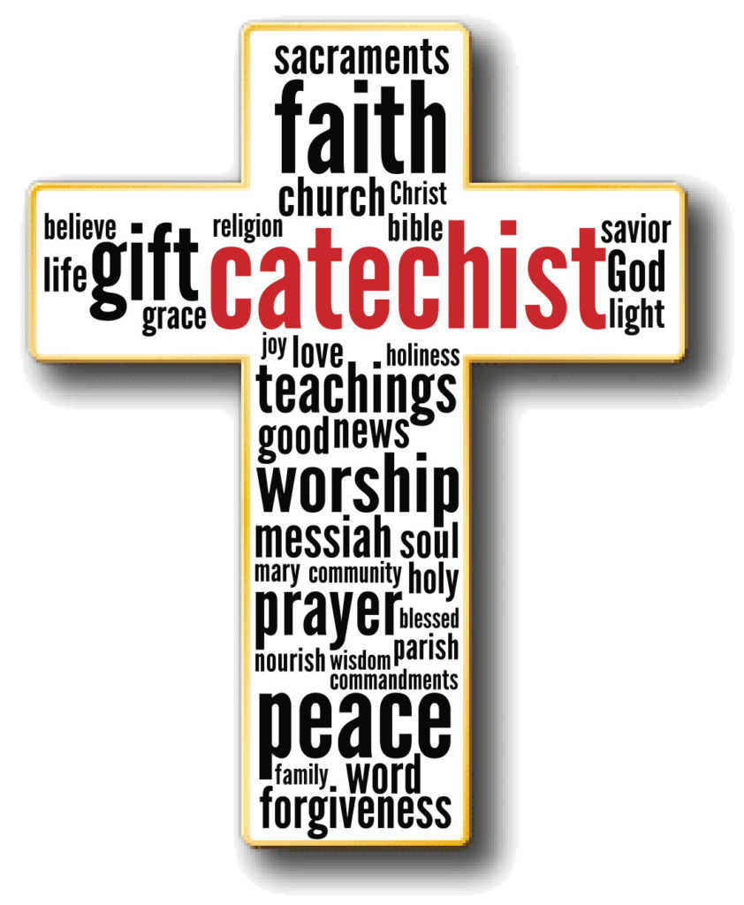
CATECHIST INTEREST FORM
NAME: ____________________________________________________________
ADDRESS: __________________________________________________________
CELL PHONE#: _________________________ OTHER #: ___________________
EMAIL ADDRESS: ____________________________________________________

I feel called and equipped to be a:
CATECHIST | FOR…
 | 1ST Grade Preparatory for 2nd/3rd Grade
 | 2nd/3rd Grade Restored Order
 | - YEAR 1 – “Salvation History and Reconciliation”
 | - YEAR 2 – “Confirmation and Eucharist”
 | Youth Confirmation – 4th/5th/6th Grade
 | Teen Confirmation – 7th – 12th Grade
 | Adult Confirmation – 18+
 | R.C.I.A. for ADULTS - 18+
 | R.C.I.Y. for YOUTH – 7th – 12th Grade
 | R.C.I.C. for Children – 4th – 6th Grade
 | ALPHA for Teens – 7th-12th Grade
 | OTHER:
 | Breaking Open the Word for RCIA
 | Children’s Liturgy
 | VBS
 | Special Classes, i.e. Baptism prep for Students, Parents, Godparents; Confirmation Sponsors
 | Catechesis classes for Parents
 | Family Catechesis
 | Adult Faith Formation Programs/Events
CO-CATECHIST | FOR… (CHOOSE FROM ABOVE)
SPECIAL EVENTS COORDINATOR  (Circle those that you are interested in coordinating) | i.e. Halloween, Family Advent Day, Christmas celebration, Lenten event, Stations of the Cross, Social Justice Teaching event, Tour of the Church, Presentation on the Mass,
 | OTHER:
MINISTER OF HOSPITALITY for Special Events | ALPHA, Receptions following reception of sacraments, special events (see above), etc.
OTHER…..

