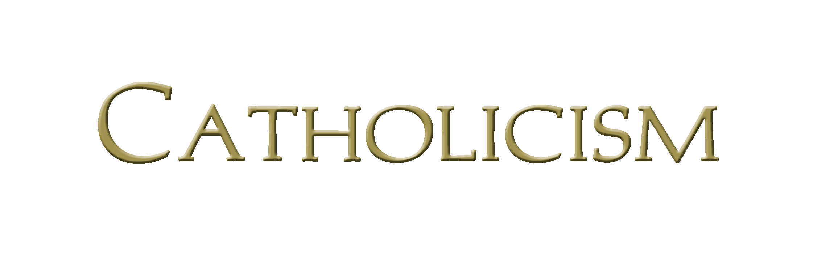Father Robert Barron’s Catholicism Series Study Program Registration

To register for the upcoming Catholicism Series program, please complete this form and return it to the parish office, Attn: Linda, along with the $20 registration fee by July 18, 2019.

Name __________________________________________________________________________________

Address________________________________________________________________________________

City ______________________ Preferred phone number: ___________________________

Email address: ________________________________________________________________________

Have you ever participated in an adult formation program? ________ Yes _______ No

If yes, approximately how many programs have you completed? ________________

Questions or More Information? Call Linda Blincow, DRE or email –
303-288-2442, est. 132 or lblincow@assumptiondenver.org
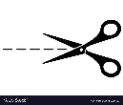
_ _ _ _ _ _ _ _ _ _ _ _ _ _ _ _ _ _ _ _ _ _ _ _ _ _ _ _ _ _ _ _ _ _ _ _ _ _ _ _ _ _ _ _ _ _ _ _ _ _ _ _ _ _

(RETURN TOP PORTION - REGISTRATION FORM;
KEEP THE BOTTOM PORTION, - DATES, TIMES, LOCATION - FOR YOUR RECORDS.)
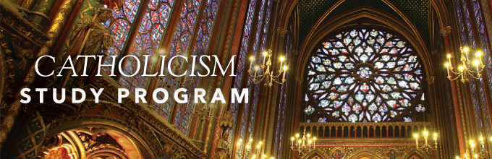
A 12- Session Small Group Study (Minimal homework required)
THURSDAYS, August 1, 8, 15, 22, 29, September 5, 12, 19, 26
TWO TIME OPTIONS: 1:00 – 3:00 p.m. OR 6:30-8:30pm
LOCATION: Library Room in the Parish Office Building

Journey Around the World and Deep into the Faith with Bishop Robert Barron
The CATHOLICISM Faith Formation Program bring the beauty, goodness and truth of the Church to life so that you can better understand and share your faith.

