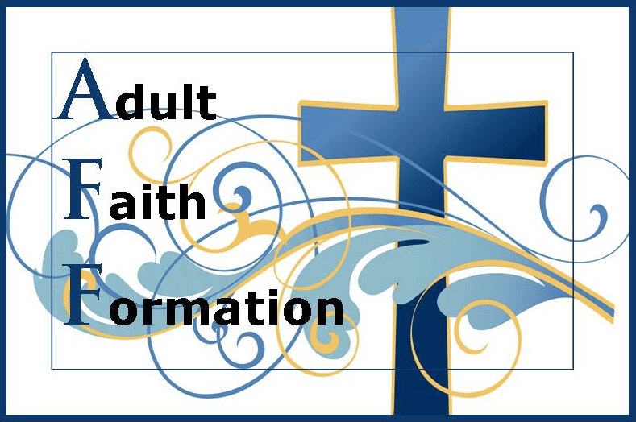
ADULT FAITH FORMATION UPCOMING OPPORTUNITIES FOR SPIRITUAL GROWTH
These classes are open to
Lifelong and Ongoing!

adults age 18 – 99!

- THURSDAY, OCTOBER 24 - ONE-DAY EVENT! – “Faith Clips” by Bishop Barron - Join Bishop Robert Barron as he answers 50 frequently asked questions about the Catholic faith on a diverse range of topics from God, Jesus and the Trinity to the sacraments, prayer and the spiritual life. Q&A video with group discussion (2.5 hours) – 1:00-3:30pm OR 6:30-9:00pm in the Library Room. NO CHARGE|NO PRE-REGISTRATION!

- SATURDAY, NOVEMBER 2 – ONE DAY EVENT! – Saints Retreat, 9:00am – 4:00pm. Using “Who Cares About the Saints?” by Fr. James Martin, SJ, a video companion to his book “My Life with the Saints,” we will have a fun day exploring the lives and different saints and discover how the saints guide us throughout our earthly journeys and how they help each of us find holiness in our own lives.
  - 9:00am – 4:00pm in the Library room. Includes continental breakfast, lunch, and snack
  - Opportunity for Confession at 4:30 and Mass at 5:00pm
  - $20 fee includes all materials – Registration Required – call or email Linda

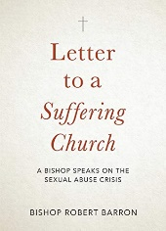
- THURSDAY, NOVEMBER 7 – ONE DAY EVENT! – “Letter to a Suffering Church” by Bishop Robert Barron
  - Two time options: 1:00-3:30pm OR 6:30-9:00pm
  - PRE-REGISTRATION by OCTOBER 17TH REQUIRED! CALL, 303-288-2442, EXT 132 OR EMAIL, lblincow@assumptiondenver.org, to reserve a copy of the book. (Only 50 books available.)
  - Each participant will get a copy of the book (NO CHARGE) in advance of the class. This is required reading for the class! Reserve your copy and pick it up after Masses on Oct 19/20
  - On the day of the class, we will have group prayer and discussions with questions provided by Bishop Barron. We will also listen to short video clips by Bishop Barron on each section of the book.
  - Please extend this invitation to anyone you know who may want to listen to Bishop Barron who wrote this book for his fellow Catholics who feel demoralized, scandalized, angry beyond words, and ready to quit.
“The sexual abuse scandal has gripped the Catholic Church for the past thirty years, and continues to wreak havoc even today. It's been a diabolical masterpiece, one that has compromised the work of the Church in every way and has left countless lives in ruins. Many Catholics are understandably asking, “Why should I stay? Why not abandon this sinking ship before it drags me or my children under?"
In this stirring manifesto, Bishop Robert Barron, founder of Word on Fire Catholic Ministries and Auxiliary Bishop of the Archdiocese of Los Angeles, explains why this is not the time to leave, but the time to stay and fight. Reading the current crisis through the lenses of Scripture and Church history, Bishop Barron shows that we have faced such egregious scandals before; that the spiritual treasures of the Church were preserved by holy men and women who recommitted themselves to fighting evil; and that there is a clear path forward for us today.
For Catholics questioning their faith, searching desperately for encouragement and hope, this book will offer reasons to stay and fight for the Body of Christ.”

- SATURDAY, DECEMBER 14 – ONE DAY EVENT! – Advent/Infancy Narratives Retreat (Details about this retreat to follow)
  - 9:00am – 4:00 pm in the Library room. Includes continental breakfast, lunch, and snack
  - Opportunity for Confession at 4:30 and Mass at 5:00pm
  - $20 fee includes all materials – Registration Required – call or email Linda

- Little Rock Scripture Study – “Matthew” Part I
  - Five (5) Sessions: Thursdays, January 9 – February 6, 2020
  - 1:00-3:00 p.m. OR 6:30-8:30 p.m. in the Library room.
  - $10 book fee - Registration Required – call or email

- SATURDAY, FEBRUARY 29 – ONE DAY EVENT! – Lenten Retreat (Details about this retreat to follow)
  - 9:00am – 4:00 pm in the Library room. Includes continental breakfast, lunch, and snack
  - Opportunity for Confession at 4:30 and Mass at 5:00pm
  - $20 fee includes all materials – Registration Required – call or email Linda

- Little Rock Scripture Study – “Matthew” Part II
  - Four (4) Sessions: Thursdays, March 5 – March 26, 2020
  - 1:00-3:00 p.m. OR 6:30-8:30 p.m. in the Library room.
  - $10 book fee - Registration Required – call or email

We will be adding other events and programs throughout the year to enhance your spiritual growth. Stay tuned…

VISIT OUR WEBSITE – WWW.assumptiondenver.org – or call or EMAIL linda blincow, dre, with questions or to register - 303-288-2442, ext. 132 or lblincow@assumptiondenver.org

